

**LOW Level Design**

Author: Team  
Creation Date: 2024-06-06

Last Updated by:   
Last Updated:

Revision: V1.0

Document Control

Information

|  |
| --- |
| File name |
| Building a Timesheet application for NWS. |

Change Record

|  |  |  |  |
| --- | --- | --- | --- |
| Date | Author | Revision | Change Reference |
| 2024-06-06 | 1.Pooja More  2.Asma Somlapurkar | 1.0 | Initial version |
|  |  |  |  |
|  |  |  |  |
|  |  |  |  |
|  |  |  |  |

Internal and external Reviewers

|  |  |
| --- | --- |
| Name | Department |
| Yogesh Oza |  |
| Dinesh Prajapati |  |
|  |  |

Distribution

|  |  |  |
| --- | --- | --- |
| Copy No. | Name | Location |
|  |  |  |
|  |  |  |
|  |  |  |

Table of content

|  |  |
| --- | --- |
| **Sr.No.** | **Content** |
| 1 | Overview |
| 2 | Module Name |
| 3 | Standard Object  -Module Description |
| 4 | UI Design |
| 5 | Module(Field & Datatype) |
| 6 | Flow Diagram |

# Overview:

A timesheet is an application used to track the working hours of employees. It provides a record of the time an employee spends on different tasks or projects. This overview will cover the main components, purposes, and benefits of using a timesheet

### Document Purpose:

1. **Login**: Employee logs in using their credentials.
2. **Create Timesheet**: Employee selects a particular date and creates a new timesheet.
3. **Add Entries**: Employee adds daily work entries to the timesheet.
4. **View Timesheet**: Employee can view the timesheet for a selected week and also as specific day.
5. **Update Timesheet**: Employee can update any existing entries in their timesheet.
6. **Submit Timesheet**: Once completed, the employee submits the timesheet for approval

# Module

**1)Timesheet**

* Monthly sheet
* Weekly sheet

# Standard Object

# Timesheet

|  |  |  |  |
| --- | --- | --- | --- |
| End User | Reqirements | Action | Activities |
| |  | | --- | | Employee |  |  | | --- | |  |  |  | | --- | |  |  |  | | --- | |  | | Login to access the timesheet system | Enter username and password | Validate credentials, establish session, redirect to dashboard |
| |  | | --- | | Employee |  |  | | --- | |  |  |  | | --- | |  |  |  | | --- | |  | | Create a new timesheet for a specific week | Select date, pop up window to "Create Timesheet" | Display empty timesheet form, initialize timesheet entry |
| |  | | --- | | Employee |  |  | | --- | |  |  |  | | --- | |  |  |  | | --- | |  | | Add daily work entries | Enter hours, task description | Save entry to database, update total hours for the week |
| |  | | --- | | Employee |  |  | | --- | |  |  |  | | --- | |  |  |  | | --- | |  | | View timesheet details for a specific day and week | Select week from calendar/view | Fetch timesheet data, display entries |
| |  | | --- | | Employee |  |  | | --- | |  |  |  | | --- | |  |  |  | | --- | |  | | Update existing timesheet entries | Edit hours or task description | Update entry in database, recalculate total hours |
| |  | | --- | | Employee |  |  | | --- | |  | | Submit completed timesheet for approval | |  | | --- | | Click "Submit" |  |  | | --- | |  | | Change status to submitted, notify manager |
| Employee | Track status of submitted timesheets | View status on dashboard | Fetch status from database, display status (e.g., submitted, approved, rejected) |
| Manager | Approve or reject submitted timesheets | |  | | --- | | Select timesheet, click "Approve" or "Reject" |  |  | | --- | |  | | Update status in database, notify employee |
| |  | | --- | | Admin |  |  | | --- | |  |  |  | | --- | |  | | Manage employee accounts and roles | Add, edit, or remove employee | |  | | --- | | Update employee records in database | |

# UI Design

# 

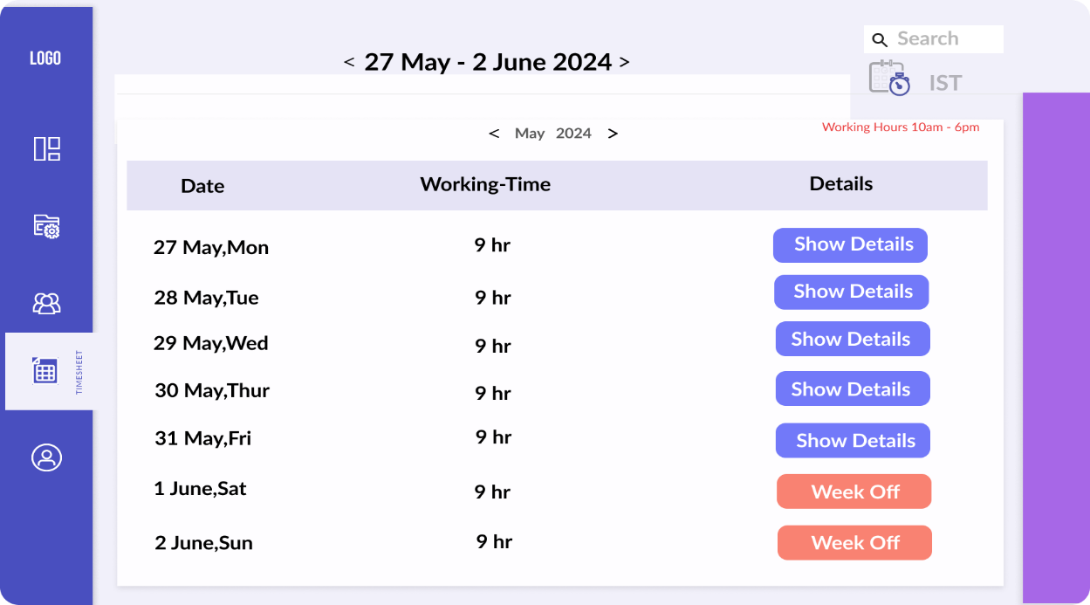

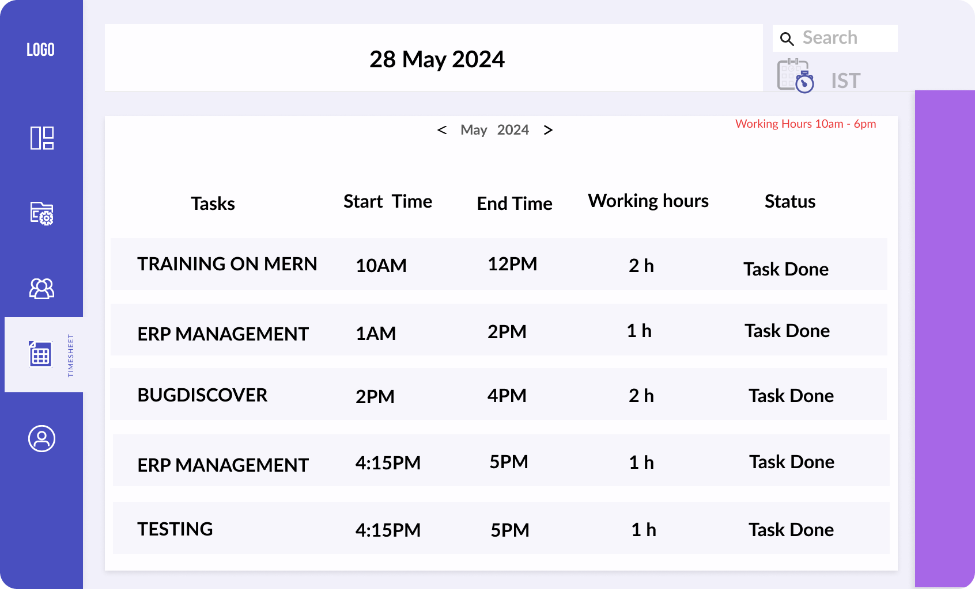

# Module [Field & datatype]:

**Timesheet Modules:**

|  |  |
| --- | --- |
| **Fields** | **Data-Types** |
| Id(PK) | String |
| date | Date_Time |
| task | String |
| hourWorked | Float |
| userid(FK) | String |

# Flow Diagram:

